- Ans
• Poisson processes are a fundamental concept in probability theory and stochastic
processes.
• They are widely used to model random occurrences of events happening over time or
space.
• Named after the French mathematician Siméon Denis Poisson, these processes have
many applications, including modeling arrival times in queuing systems, radioactive
decay, telecommunications, and more.

Formally, a Poisson process can be described as follows:
• Let N(t) be the random variable representing the number of events
that have occurred in the interval [0, t].
• The process is a Poisson process if it satisfies the following
conditions:
- N(0) = 0, meaning there are no events at time t = 0.
- For any t ≥ 0, the random variable N(t) has a Poisson distribution
with parameter λt, where λ is the average rate of events per unit time.
Mathematically, the probability mass function of N(t) is given by:

P(N(t) = k) = (e^(-λt) * (λt)^k) / k!, for k = 0, 1, 2, ...

• Here, e is Euler's number (approximately 2.71828), and k! represents
the factorial of k.

- Ans
• The simple differential equation can model the simplest continuous system and
they can have one or more linear differential equation with constant coefficients.
• It is then often possible to solve the model without using simulation technique .
• However when non linearity involves into the model, it may be impossible or at
least very difficult to solve such model without simulation.

Using analog method
• The general method by which analog computers are applied can be demonstrated using
second order differential equation.

Mẍ+D ẋ +k x = kF(t)

• Solving the equation for the highest order derivate gives,

Mẍ=k F(t) − Dẋ −k x

• Suppose a variable representing the input F(t) is supplied, assume there exists variables
representing −x and −ẋ .
• These three variables can be scaled and added to produce Mẍ.
• Integrating it with a scale factor 1⁄Mproduces ẋ .
• Changing sign produces −ẋ , further integrating produces −x, a further sign inverter is
included to produce +x as output.
• When a model has more than one independent variable, a separate block diagram is drawn
for each independent variable and where necessary, interconnections are made between the
diagrams.

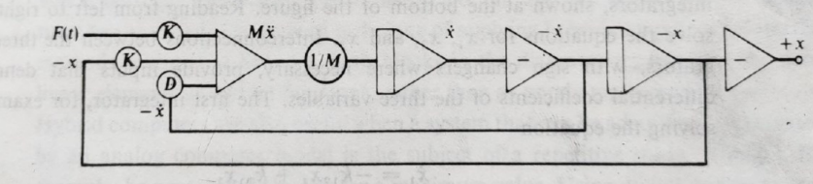

- Ans
• Hybrid simulation, also known as mixed simulation, is a computational method that
combines two or more different simulation techniques to model and analyze complex
systems or phenomena.
• The goal of hybrid simulation is to take advantage of the strengths of each simulation
method while mitigating their individual limitations.
• It allows researchers and engineers to tackle problems that cannot be adequately
addressed using a single simulation approach.
• In hybrid simulation, the system being studied is divided into multiple sub-components,
and each sub-component is simulated using the most appropriate simulation method.

Difference
• In a fixed time-step (interval Oriented) model a timer is simulated by
the computer, this timer is updated by a fixed time interval τ, and the
system is examined to see if any event has taken place during this time
interval, all events that take place during that interval are treated as if
they occurred simultaneously at the end of this interval.
• In a next-event (or event-to-event) model the computer advances time
to the occurrence of the next event, thus it shifts from one event to the
next; the system state does not change in between.
• When something of interest happens to the system, the current time is
kept track of.

- Ans
• It is a numerical computation method that consists of extensive experimental
sampling with random numbers.
• For Example, the integral of a single variable over a given range corresponds to
finding the area under the graph representing the function.
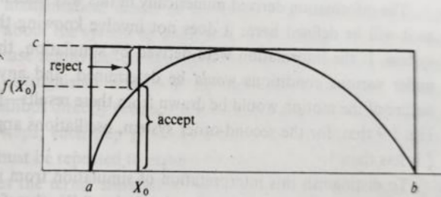
As shown in the figure above, the graph of the function is then contained within a
rectangle with sides of length c, and b-a. If we pick points at random within the
rectangle, and determine whether they lie beneath the curve or not, it is apparent
that, providing the distribution of selected points is uniformly spread over the
rectangle. The fraction of the points falling on or below the curve should be
approximately the ratio of the area under the curve to the area of the rectangle. If
N points are used and n of them fall under the curve, then, approximately,
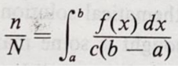
The accuracy improves as the number of N increases. When it is decided that the
sufficient points has been taken, the value of integral is estimated by multiplying
n/N with the area of rectangle, c(b-a).

The idea is to simulate random (x, y) points in a 2-D plane with domain as a
square of side 1 unit. Imagine a circle inside the same domain with same diameter
and inscribed into the square. We then calculate the ratio of number points that
lied inside the circle and total number of generated points. Refer to the image
below:
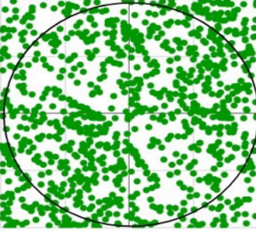
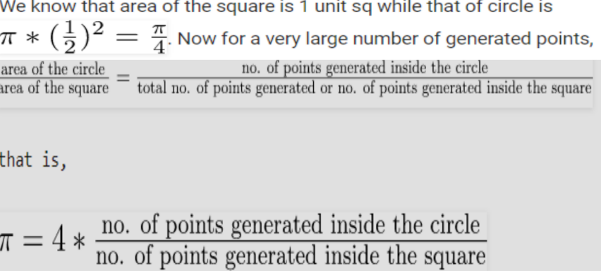

- Ans
The simulation clock is a fundamental concept in simulations.
It is a virtual clock that represents the current time within the simulation. The
simulation clock progresses in discrete steps or increments, each representing a
fixed or variable time interval. At each time step, the simulation updates the state
of the system and processes events that occur during that particular time.

Aspect | Clock Time | Simulation Time
Definition | Actual time elapsed in the real world. | Time progression as defined within the simulation.
Nature | Real-world time measured in seconds, minutes, etc. | Simulated time, not tied to real-world time.
Dependency | Depends on hardware and software speed. | Depends on simulation design and objectives.
Example | Running a simulation for 10 minutes in real time. | Simulating a year of traffic flow in a few seconds.

Digital Simulator:
- Uses computers to simulate systems mathematically and logically.
- Deals with discrete data or digital representations of processes.
- Example: Simulating a digital circuit using software like MATLAB.
Analog Simulator:
- Models systems using physical analogs of the system being simulated.
- Relies on continuous data represented by electrical voltages or mechanical processes.
- Example: Old flight simulators using electrical circuits to replicate the behavior of an airplane.
- Ans
Discrete Event Simulation is a method used to model the behavior of a system where the system’s state changes at discrete points in time, typically when an event occurs. Events are specific occurrences that may alter the state of the system (such as the arrival of a customer in a bank or the completion of a task in a manufacturing process). The time between these events may vary.
For example, in a hospital simulation, discrete events might include the arrival of patients, the start of a consultation, or the completion of treatment. Each event occurs at a specific point in time, and the system’s behavior is updated as each event happens. The main goal is to analyze how the system behaves over time and estimate performance metrics such as queue lengths or waiting times.
Poisson’s arrival pattern is a statistical model used to describe random, independent events occurring over a fixed period of time or space. It is based on the Poisson distribution, which is used when events happen at a constant average rate, but the exact timing between events is random.
Key characteristics of Poisson’s arrival pattern:
- The events are independent (one event does not affect another).
- The events occur at a constant average rate (λ, lambda), such as an average of 10 calls per hour or 3 customers arriving per minute.
- Ans
In system simulation, the clock time tracks the progression of events. It is updated each time an event occurs in the simulation. The steps for updating the clock time are as follows:
Identify the Next Event: The simulation works by processing events in chronological order. To update the clock time, the next event that is scheduled to occur must be identified. Each event has a specific time associated with it.
Update the Clock Time: Once the next event is identified, the simulation updates the clock time to the time of the next event. The clock does not move continuously but instead jumps to the point in time when the event occurs.
Process the Event: After updating the clock time, the simulation processes the event, which may lead to the creation of new events. These new events will also have specific times assigned to them.
Repeat the Process: The simulation continues this process of updating the clock time, processing events, and identifying the next event until the simulation ends or reaches a predetermined condition.
This method of updating clock time is a key feature of discrete event simulation, where the simulation jumps from one event to the next, rather than progressing continuously.

